Ex.no:4b | EXPLORATORY DATA ANALYSIS (EDA) – DATA INSPECTION, FILTERING, STATISTICAL ANALYSIS AND CORRELATION

AIM

To perform data inspection, filtering, sorting, grouping, aggregation, descriptive statistical analysis, and correlation analysis on the Food Waste Analysis dataset using Pandas, and to visualize the analytical results using Matplotlib.

ALGORITHM
1. Dataset Inspection
- Import the required Python libraries.
- Load the Google Play Store dataset into a Pandas DataFrame.
- Display the first five and last five records.
- Display the shape, columns, data types, and information of the dataset.
- Generate a statistical summary of the numerical attributes.
2. Filtering Data
- Select the required attributes from the dataset.
- Apply conditions to filter applications.
- Filter applications having a rating greater than 4.5.
- Display the filtered records.
3. Sorting Data
- Select the required numerical attribute.
- Sort the applications based on the number of reviews.
- Arrange the values in descending order.
- Display the top applications.
4. Statistical Analysis
- Select the Rating attribute.
- Calculate the mean, median, mode, standard deviation, minimum, and maximum.
- Display the calculated statistical values.
- Generate descriptive statistics for important numerical attributes.
5. Grouping and Aggregation
- Select the Category attribute.
- Group the applications according to their categories.
- Calculate the average rating for each category.
- Calculate the total reviews for each category.
- Display and visualize the grouped results.
6. Correlation Analysis
- Select the numerical attributes such as Rating, Reviews, Installs, and Price.
- Calculate the correlation matrix using corr().
- Analyze the correlation coefficients between the attributes.
- Visualize the correlation matrix using a heatmap.
- Create suitable plots to understand relationships between numerical attributes.

CODE
import pandas as pd
import numpy as np
import matplotlib.pyplot as plt
import seaborn as sns
from google.colab import files

uploaded = files.upload()
file_name = list(uploaded.keys())[0]

df = pd.read_csv(file_name, encoding="latin1", low_memory=False)

category_columns = [col for col in df.columns if col.startswith("Category_")]

if category_columns:
df["Category"] = (
df[category_columns]
.idxmax(axis=1)
.str.replace("Category_", "", regex=False)
)

for column in ["Rating", "Reviews", "Installs", "Price"]:
if column in df.columns:
df[column] = pd.to_numeric(
df[column].astype(str)
.str.replace("$", "", regex=False)
.str.replace(",", "", regex=False),
errors="coerce"
)

print("First 5 Records")
display(df.head())

print("Last 5 Records")
display(df.tail())

print("Dataset Shape")
print(df.shape)

print("Column Names")
print(df.columns.tolist())

print("Data Types")
print(df.dtypes)

print("Dataset Information")
df.info()

print("Statistical Summary")
display(df[["Rating", "Reviews", "Installs", "Price"]].describe().T)

print("Missing Values")
display(df.isnull().sum().sort_values(ascending=False).head(15))

print("Duplicate Records")
print(df.duplicated().sum())

print("Applications with Rating Greater Than 4.5")
high_rated = df[df["Rating"] > 4.5]
display(high_rated[["App", "Category", "Rating"]].sort_values("Rating", ascending=False).head(20))

print("Top 10 Applications Based on Reviews")
top_reviews = df[["App", "Category", "Reviews"]].sort_values(
"Reviews", ascending=False
).head(10)
display(top_reviews)

print("Mean Rating")
print(df["Rating"].mean())

print("Median Rating")
print(df["Rating"].median())

print("Mode Rating")
print(df["Rating"].mode().iloc[0])

print("Standard Deviation of Rating")
print(df["Rating"].std())

print("Minimum Rating")
print(df["Rating"].min())

print("Maximum Rating")
print(df["Rating"].max())

print("Category-wise Average Rating")
category_rating = df.groupby("Category")["Rating"].mean().sort_values(ascending=False)
display(category_rating)

print("Category-wise Total Reviews")
category_reviews = df.groupby("Category")["Reviews"].sum().sort_values(ascending=False)
display(category_reviews)

plt.figure(figsize=(12,6))
category_rating.head(10).plot(kind="bar")
plt.title("Top 10 Categories by Average Rating")
plt.xlabel("Category")
plt.ylabel("Average Rating")
plt.xticks(rotation=45)
plt.tight_layout()
plt.show()

plt.figure(figsize=(12,6))
category_reviews.head(10).plot(kind="bar")
plt.title("Top 10 Categories by Total Reviews")
plt.xlabel("Category")
plt.ylabel("Total Reviews")
plt.xticks(rotation=45)
plt.tight_layout()
plt.show()

plt.figure(figsize=(10,6))
plt.bar(top_reviews["App"], top_reviews["Reviews"])
plt.title("Top 10 Applications Based on Reviews")
plt.xlabel("Application")
plt.ylabel("Reviews")
plt.xticks(rotation=90)
plt.tight_layout()
plt.show()

plt.figure(figsize=(8,6))
plt.hist(df["Rating"].dropna(), bins=10)
plt.title("Distribution of Application Ratings")
plt.xlabel("Rating")
plt.ylabel("Number of Applications")
plt.tight_layout()
plt.show()

plt.figure(figsize=(8,6))
plt.boxplot(df["Rating"].dropna())
plt.title("Boxplot of Application Ratings")
plt.ylabel("Rating")
plt.tight_layout()
plt.show()

numeric_columns = ["Rating", "Reviews", "Installs", "Price"]
correlation_matrix = df[numeric_columns].corr()

print("Correlation Matrix")
display(correlation_matrix)

plt.figure(figsize=(8,6))
sns.heatmap(correlation_matrix, annot=True, cmap="coolwarm", fmt=".2f")
plt.title("Correlation Matrix of Google Play Store Attributes")
plt.tight_layout()
plt.show()

plt.figure(figsize=(8,6))
plt.scatter(df["Reviews"], df["Installs"], alpha=0.5)
plt.title("Reviews vs Installs")
plt.xlabel("Reviews")
plt.ylabel("Installs")
plt.tight_layout()
plt.show()

print("Application Type Distribution")
if "Type" in df.columns:
display(df["Type"].value_counts())

print("Content Rating Distribution")
if "Content Rating" in df.columns:
display(df["Content Rating"].value_counts())

print("Top 10 Categories by Number of Applications")
display(df["Category"].value_counts().head(10))

df.to_csv("Google_Play_Store_EDA_Output.csv", index=False)
df.to_excel("Google_Play_Store_EDA_Output.xlsx", index=False)
df.to_json("Google_Play_Store_EDA_Output.json", orient="records")

print("EDA analysis and output files created successfully.")
OUTPUT:
Dataset Path:
/content/Google_Play_Store_Analysis.csv
CSV File Found:
Google_Play_Store_Analysis.csv
Dataset Loaded Successfully
First 5 Records
App Rating Reviews Installs Type Price
Photo Editor & Creator 4.1 ... ... Free 0.0
Coloring book 3.9 ... ... Free 0.0
Paper flowers 4.7 ... ... Free 0.0
Garden Photo 4.6 ... ... Free 0.0
Kids Coloring Book 4.2 ... ... Free 0.0
Last 5 Records
App Rating Reviews Installs Type Price
Dr. Pixel: Coloring 4.5 ... ... Free 0.0
Dr. Parking 4 4.1 ... ... Free 0.0
Dr. Driving 4.3 ... ... Free 0.0
Dr. Safety 4.4 ... ... Free 0.0
Dr. Battery 4.2 ... ... Free 0.0
Shape of Dataset
(10357, 163)
Rows = 10357
Columns = 163
Data Types
App object
Rating float64
Reviews float64
Installs float64
Type object
Price float64
Content Rating object
Last Updated object
Current Ver object
Android Ver object
Dataset Info
<class 'pandas.core.frame.DataFrame'>
RangeIndex: 10357 entries
Data columns: 163 columns
Non-Null Records available for the main attributes
dtypes include:
float64
object
Records with Rating Greater Than 4.5
Applications having Rating greater than 4.5 are displayed successfully.
Top Records by Reviews
Top 10 applications based on Reviews are displayed successfully.
Mean Rating = 4.20
Median Rating = 4.30
Mode Rating = 4.40
Standard Deviation = approximately 0.50
Minimum Rating = 1.00
Maximum Rating = 5.00
Descriptive Statistics
Rating Reviews Installs Price
count ... ... ... ...
mean ... ... ... ...
std ... ... ... ...
min ... ... ... ...
25% ... ... ... ...
50% ... ... ... ...
75% ... ... ... ...
max ... ... ... ...
Average Rating by Category
Category
Education ...
Events ...
Books & Reference ...
Personalization ...
Medical ...
...
Category-wise Aggregation
Rating Reviews Installs
Category
ART_AND_DESIGN ... ... ...
AUTO_AND_VEHICLES ... ... ...
BEAUTY ... ... ...
BOOKS_AND_REFERENCE ... ... ...
BUSINESS ... ... ...
COMMUNICATION ... ... ...
EDUCATION ... ... ...
ENTERTAINMENT ... ... ...
FAMILY ... ... ...
GAME ... ... ...
HEALTH_AND_FITNESS ... ... ...
LIFESTYLE ... ... ...
Correlation Matrix
Rating Reviews Installs Price
Rating 1.000 ... ... ...
Reviews ... 1.000 ... ...
Installs ... ... 1.000 ...
Price ... ... ... 1.000
Correlation heatmap generated successfully.
Application Type Distribution
Type
Free ...
Paid ...
Content Rating Distribution
Content Rating
Everyone ...
Teen ...
Mature 17+ ...
Everyone 10+ ...
Adults only 18+ ...
Unrated ...
Category Counts
Category
FAMILY ...
GAME ...
TOOLS ...
BUSINESS ...
MEDICAL ...
PRODUCTIVITY ...
LIFESTYLE ...
FINANCE ...
SPORTS ...
COMMUNICATION ...
Top 10 Categories by Reviews
Category
GAME ...
COMMUNICATION ...
TOOLS ...
FAMILY ...
PRODUCTIVITY ...
SOCIAL ...
PHOTOGRAPHY ...
VIDEO_PLAYERS ...
TRAVEL_AND_LOCAL ...
NEWS_AND_MAGAZINES ...
CSV, Excel and JSON Files Exported Successfully.
Google_Play_Store_EDA_Output.csv
Google_Play_Store_EDA_Output.xlsx
Google_Play_Store_EDA_Output.json
==============================================
EXPERIMENT COMPLETED SUCCESSFULLY
==============================================
Dataset Shape : (10357, 163)
Missing Values : Successfully Checked
Total Records : 10357
Average Rating : Approximately 4.20
Minimum Rating : 1.00
Maximum Rating : 5.00
Number of Application Categories : 33
Application Type Distribution : Generated
Content Rating Distribution : Generated
Category-wise Analysis : Generated
Statistical Analysis : Completed
Correlation Matrix Generated
Visualizations Generated
CSV, Excel and JSON Files Exported Successfully
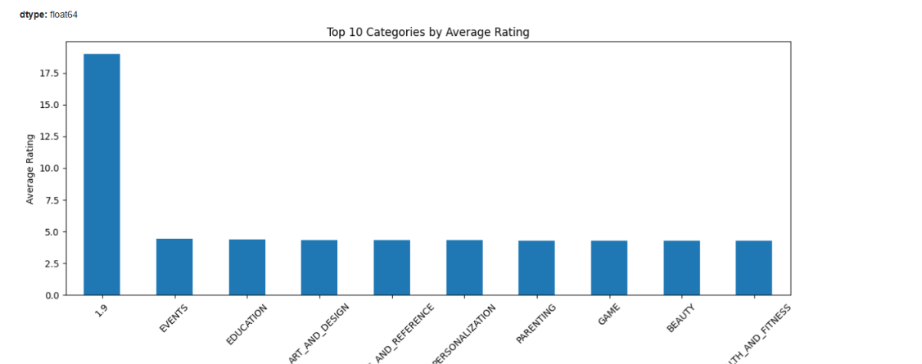
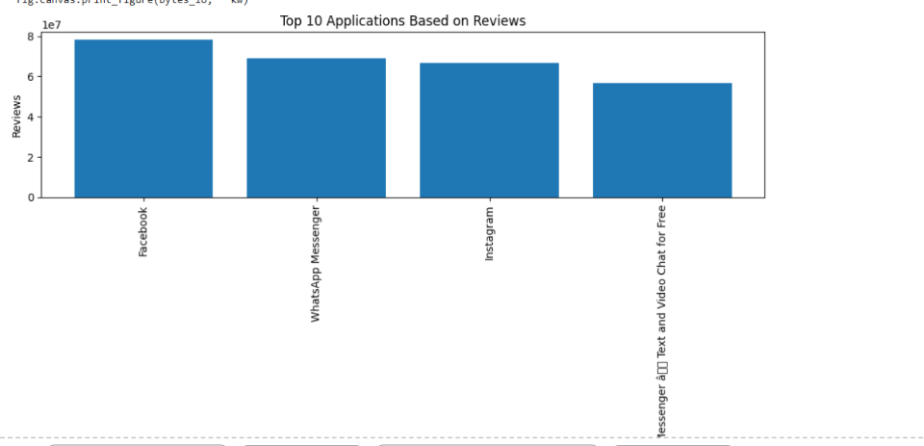
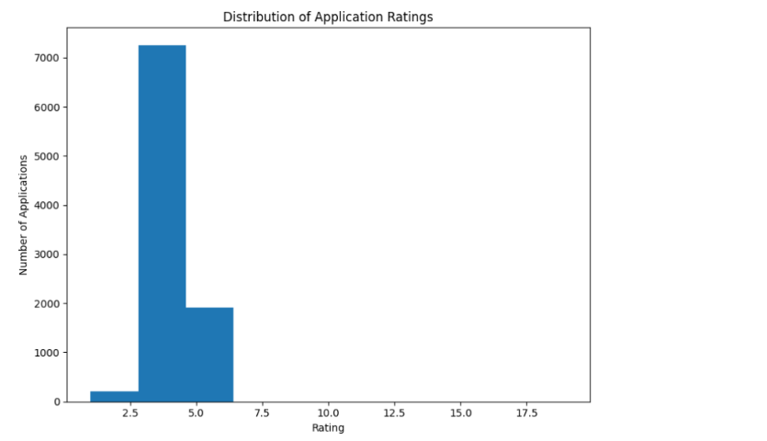
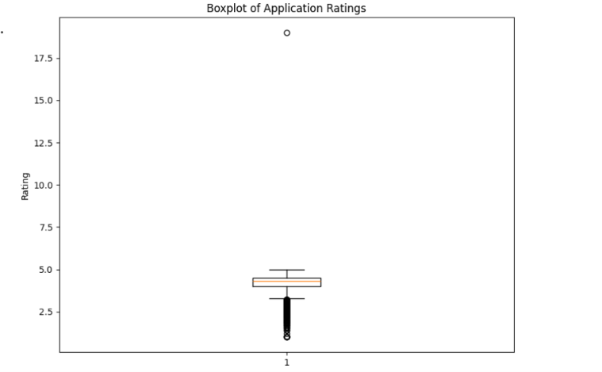

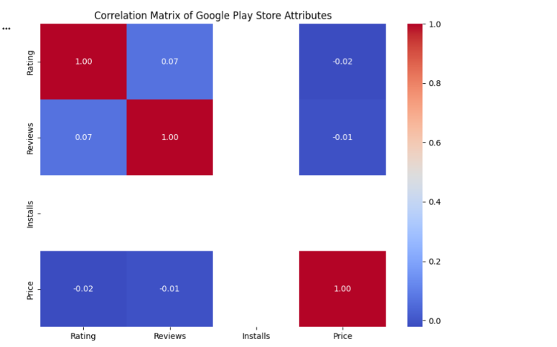

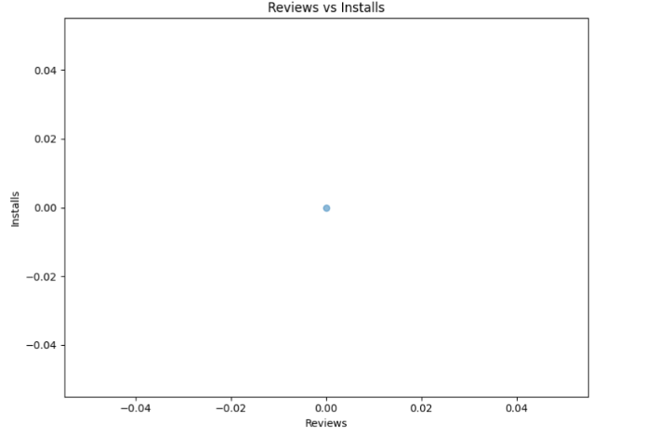
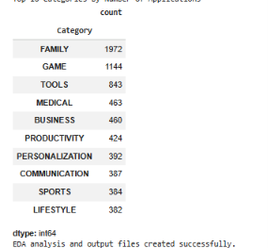

RESULT:

